**Question 1: Implement Quick Sort Algorithm on string array using left value as first pivoting value.**

**Code:**

static void Main(string[] args)

{

Console.WriteLine("Enter the number of names you want to add");

int n = Convert.ToInt32(Console.ReadLine());

string[] array = new string[n];

for(int i=0;i< n; i++)

{

Console.WriteLine("Enter name");

array[i] = Console.ReadLine();

}

Console.WriteLine("Array before sorting");

for (int i = 0; i < array.Length; i++)

{

Console.WriteLine(array[i]);

}

QuickSort(array, 0, (array.Length-1));

Console.WriteLine("Array after sorting");

for (int i = 0; i < array.Length; i++)

{

Console.WriteLine(array[i]);

}

}

public static void QuickSort(string[] A, int LB,int UB)

{

if (LB <= UB)

{

int Pv = Partition(A, LB, UB);

QuickSort(A, LB, Pv - 1);

QuickSort(A, Pv + 1, UB);

}

return;

}

public static int Partition(string[] A, int LB, int UB)

{

int Pv = LB,Lo=LB+1, Hi=UB;

while(Lo<=UB && Hi >= LB)

{

if (A[Lo].CompareTo(A[Pv]) < 0)

{

Lo++; continue;

}

if (A[Hi].CompareTo(A[Pv]) > 0)

{

Hi--;continue;

}

if (Lo < Hi)

{

string temp1 = A[Hi];

A[Hi] = A[Lo];

A[Lo] = temp1;

}

else

{

break;

}

}

string temp = A[Pv];

A[Pv] = A[Hi];

A[Hi] = temp;

Pv = Hi;

return Pv;

}

**Output:**

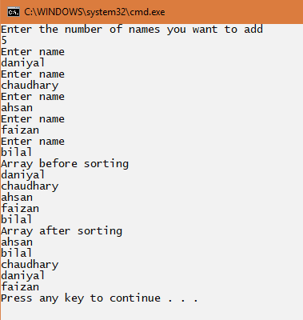

**Question 2: Implement Quick Sort Algorithm and design Windows Form Application in which you have to sort user input values in ascending and descending order as user requires, take right value as first pivoting value and show all the pivot values in a sequence they are selected.**

**Code:**

**QuickSort Class:**

class QuickSort

{

public static List<int> PVs = new List<int>();

public static int Partition(string[] A, int LB, int UB)

{

int Pv = UB, Lo = LB , Hi = UB-1;

while (Lo <= UB && Hi >= LB)

{

if (int.Parse(A[Hi]) > int.Parse(A[Pv]))

{

Hi--; continue;

}

if (int.Parse(A[Lo]) < int.Parse(A[Pv]))

{

Lo++; continue;

}

if (Lo < Hi)

{

string temp1 = A[Hi];

A[Hi] = A[Lo];

A[Lo] = temp1;

}

else

{

break;

}

}

string temp = A[Pv];

A[Pv] = A[Lo];

A[Lo] = temp;

Pv = Lo;

return Pv;

}

public static void QuickSorting(string[] A, int LB, int UB)

{

if (LB <= UB)

{

int Pv = Partition(A, LB, UB);

PVs.Add(Pv);

QuickSorting(A, LB, Pv - 1);

QuickSorting(A, Pv + 1, UB);

}

return;

}

public static int PartitionDescending(string[] A, int LB, int UB)

{

int Pv = UB, Lo = LB, Hi = UB-1;

while (Lo <= UB && Hi >= LB)

{

if (int.Parse(A[Hi]) < int.Parse(A[Pv]))

{

Hi--; continue;

}

if (int.Parse(A[Lo]) > int.Parse(A[Pv]))

{

Lo++; continue;

}

if (Lo < Hi)

{

string temp1 = A[Hi];

A[Hi] = A[Lo];

A[Lo] = temp1;

}

else

{

break;

}

}

string temp = A[Pv];

A[Pv] = A[Lo];

A[Lo] = temp;

Pv = Lo;

return Pv;

}

public static void QuickSortingDescending(string[] A, int LB, int UB)

{

if (LB <= UB)

{

int Pv = PartitionDescending(A, LB, UB);

PVs.Add(Pv);

QuickSortingDescending(A, LB, Pv - 1);

QuickSortingDescending(A, Pv + 1, UB);

}

return;

}

**Form1 Class:**

public partial class Form1 : Form

{

public Form1()

{

InitializeComponent();

}

private void button3_Click(object sender, EventArgs e)

{

Application.Exit();

}

private void btnclose_Click(object sender, EventArgs e)

{

Application.Exit();

}

private void button1_Click(object sender, EventArgs e)

{

InputTxt.Text = OutputTxt.Text = PivotTxt.Text= string.Empty;

OrderBox.Text = string.Empty;

}

public void RefreshAnswers()

{

OutputTxt.Text = PivotTxt.Text = string.Empty;

}

private void SortBtn_Click(object sender, EventArgs e)

{

try

{

QuickSort.PVs.Clear();

RefreshAnswers();

if (OrderBox.Text == "Ascending")

{

string input = InputTxt.Text;

string[] array = input.Split(',');

QuickSort.QuickSorting(array, 0, (array.Length - 1));

for (int i = 0; i < array.Length; i++)

{

OutputTxt.AppendText(array[i] + "\n");

}

string Pivots = "";

for (int i = 0; i < QuickSort.PVs.Count; i++)

{

Pivots += array[QuickSort.PVs[i]];

if (i < QuickSort.PVs.Count - 1)

{

Pivots += ",";

}

}

PivotTxt.Text = Pivots;

}

else if (OrderBox.Text == "Descending")

{

string input = InputTxt.Text;

string[] array = input.Split(',');

QuickSort.QuickSortingDescending(array, 0, (array.Length - 1));

for (int i = 0; i < array.Length; i++)

{

OutputTxt.AppendText(array[i] + "\n");

}

string Pivots = "";

for (int i = 0; i < QuickSort.PVs.Count; i++)

{

Pivots += array[QuickSort.PVs[i]];

if (i < QuickSort.PVs.Count - 1)

{

Pivots += ",";

}

}

PivotTxt.Text = Pivots;

}

else

{

MessageBox.Show("Kindly select sorting type");

}

}

catch (Exception)

{

MessageBox.Show("An error occured");

}

}

**Output: Ascending:**

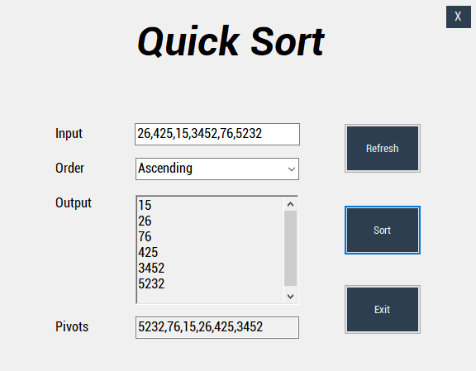

**Descending:**

